**Lab Exercise 4**

**Working with Docker Networking**

**Step 1: Understanding Docker Default Networks**

Docker provides three default networks:

* bridge: The default network when a container starts.
* host: Bypasses Docker’s network isolation and attaches the container directly to the host network.
* none: No networking is available for the container.

**1.1. Inspect Default Networks**

Check Docker's default networks using:

docker network ls

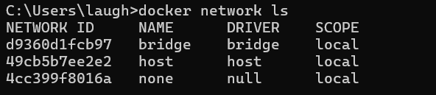

**1.2. Inspect the Bridge Network**

docker network inspect bridge

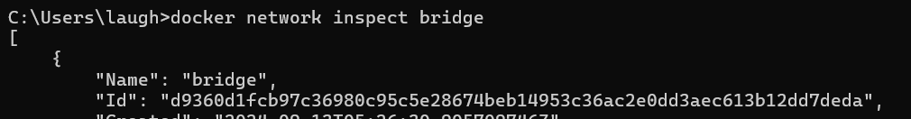



Currently we can see that there are no containers connect to this bridge

This command will show detailed information about the bridge network, including the connected containers and IP address ranges.

**Step 2: Create and Use a Bridge Network**

**2.1. Create a User-Defined Bridge Network**

A user-defined bridge network allows containers to communicate by name instead of IP.

docker network create my_bridge

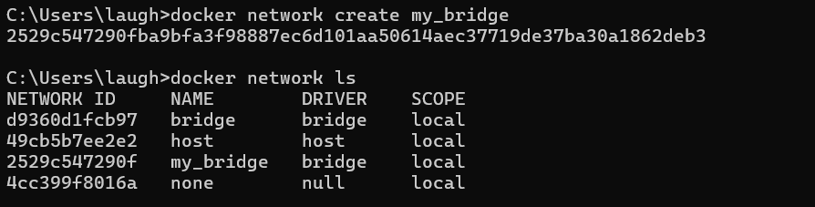

**2.2. Run Containers on the User-Defined Network**

Start two containers on the newly created my_bridge network:

docker run -dit --name container1 --network my_bridge busybox

docker run -dit --name container2 --network my_bridge busybox

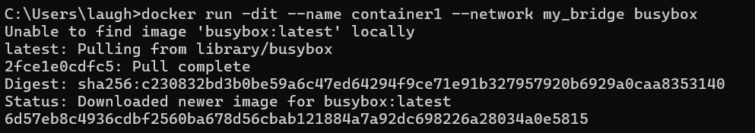



**Inspecting my_bridge again:  
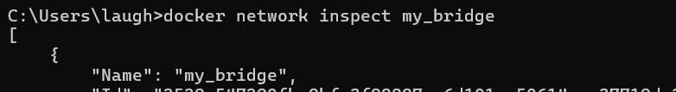**

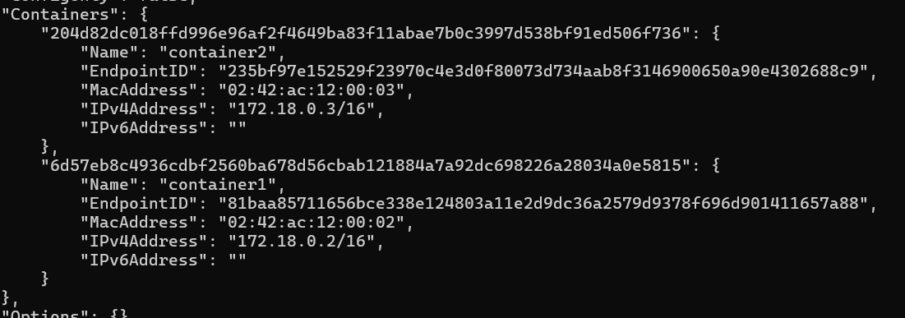

These containers are now connect to the bridge network my_bridge

**2.3. Test Container Communication**

Execute a ping command from container1 to container2 using container names:

docker exec -it container1 ping container2

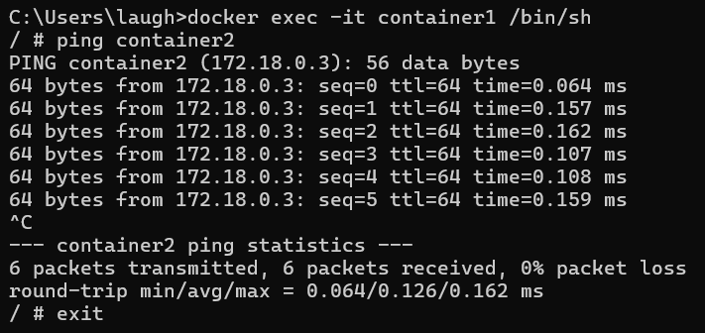

The containers should be able to communicate since they are on the same network.

**Step 3: Disconnect and Remove Networks**

**3.1. Disconnect Containers from Networks**

To disconnect container1 from my_bridge:

docker network disconnect my_bridge container1

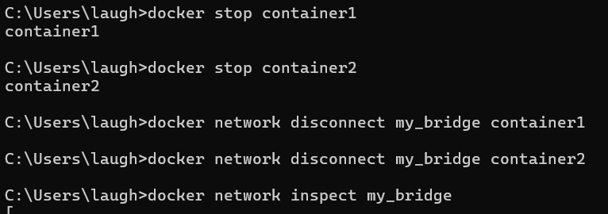

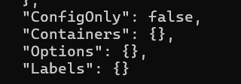

**4.2. Remove Networks**

To remove the user-defined network:

docker network rm my_bridge

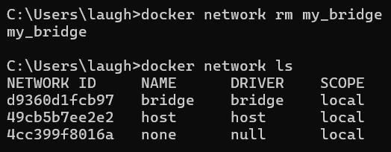

**Step 4: Clean Up**

Stop and remove all containers created during this exercise:

docker rm -f container1 container2



